Low Level Design (HLD)
Telecom Churn Analytics
Business Intelligence

Written By | Harshad Khedekar
Document Version | 0.3
Last Revised Date

DOCUMENT CONTROL
Change Record:
VERSION | DATE | AUTHOR | COMMENTS
0.1 |  |  | Introduction and architecture defined
0.2 |  |  | Architecture & Architecture description appended and updated.

Reviews:
VERSION | DATE | REVIEWER | COMMENTS
0.3 |  |  | Unit test cases to be added

Approval Status:
VERSION | REVIEW DATE | REVIEW BY |  | APPROVED BY | COMMENTS
0.3

Contents

Sr.No. | Content | Page No.
1. | Introduction | 4
1.1 | What is low level design document? | 4
1.2 | scope | 4
2. | Architecture | 5
3. | Architecture description | 5
3.1 | Data Description | 6
3.2 | Web scrapping | 9
3.3 | Data transformation | 9
3.4 | Data insertion into database | 9
3.5 | Connection with sql server | 9
3.6 | Export data from database | 10
3.7 | Deployment | 10

1. Introduction
1.1 What is Low-Level design document?
The goal of the LDD or Low-level design document (LLDD) is to give the internal logic design of the actual program code for the House Price Prediction dashboard. LDD describes the class diagrams with the methods and relations between classes and programs specs. It describes the modules so that the programmer can directly code the program from the document.

1.2 Scope
Low-level design (LLD) is a component-level design process that follows a step-by-step refinement process. The process can be used for designing data structures, required software architecture, source code and ultimately, performance algorithms. Overall, the data organization may be defined during requirement analysis and then refined during data design work.

2. Architecture

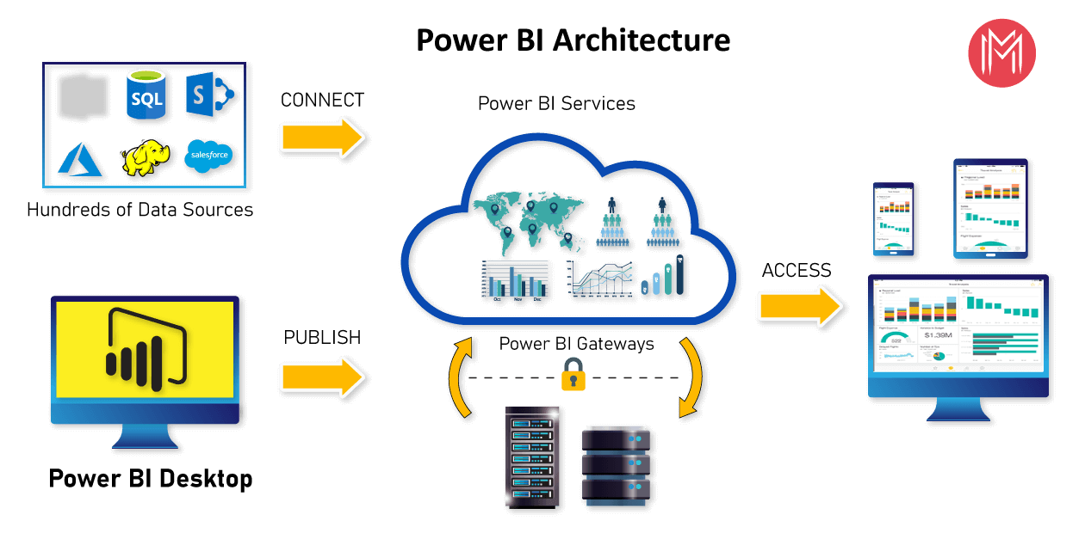

Power BI architecture is a service built on top of Azure. There are multiple data sources that Power BI can connect to. Power BI Desktop allows you to create reports and data visualizations on the dataset. Power BI gateway is connected to on-premise data sources to get continuous data for reporting and analytics. Power BI services refer to the cloud services that are used to publish Power BI reports and data visualizations. Using Power BI mobile apps, you can stay connected to their data from anywhere. Power BI apps are available for Windows, iOS, and Android platforms.

Power BI Service
Power BI service is the Software as a Service (SaaS) part of Power BI. It is also known as Power BI Online. To access Power BI Service, you need to log in to Power BI service.
It allows you to connect to data, create reports and dashboards, and ask questions about your data.
Now, as you have understood what is Power BI, its architecture, and services, let us now understand about Dashboards in Power BI.

Power BI Dashboard
Power BI Dashboard is a single page visualization to tell a story. The visualizations on a dashboard are generated from reports, and each report is based on one dataset. A single page dashboard is known as a Canvas. Below is a Finance Dashboard published on Power BI Service.

The visualizations you see on the dashboard are called Tiles and are pinned to the dashboard by report designers.

Power BI allows you to create different reports on Power BI Desktop. These reports can be published on the Power BI dashboard using the Power BI service. A Power BI report created on Power BI Desktop can be published on to Power BI Service by clicking on the Publish button.

What is Power BI ?
Power BI is a technology-driven business intelligence tool provided by Microsoft for analysing and visualizing raw data to present actionable information. It combines business analytics, data visualization, and best practices that help an organization to make data-driven decisions. In February 2019, Gartner confirmed Microsoft as Leader in the "2019 Gartner Magic Quadrant for Analytics and Business Intelligence Platform" as a result of the capabilities of the Power BI platform.
Power BI is a business analytics service provided by Microsoft that lets you visualize your data and share insights. It converts data from different sources to build interactive dashboards and Business Intelligence reports.

Why Power BI?
Following are the reasons why Power BI is so popular and needed in the BI domain:

1. Access to Volumes of Data from Multiple Sources
Power BI can access vast volumes of data from multiple sources. It allows you to view, analyze, and visualize vast quantities of data that cannot be opened in Excel. Some of the important data sources available for Power BI are Excel, CSV, XML, JSON, pdf, etc. Power BI uses powerful compression algorithms to import and cache the data within the.PBIX file.

2. Interactive UI/UX Features
Power BI makes things visually appealing. It has an easy drag and drops functionality, with features that allow you to copy all formatting across similar visualizations.

3. Exceptional Excel Integration
Power BI helps to gather, analyse, publish, and share Excel business data. Anyone familiar with Office 365 can easily connect Excel queries, data models, and reports to Power BI Dashboards.

4. Accelerate Big Data Preparation with Azure
Using Power BI with Azure allows you to analyse and share massive volumes of data. An azure data lake can reduce the time it takes to get insights and increase collaboration between business analysts, data engineers, and data scientists.

5. Turn Insights into Action
Power BI allows you to gain insights from data and turn those insights into actions to make data-driven business decisions.

6. Real-time Stream Analytics
Power BI will enable you to perform real-time stream analytics. It helps you fetch data from multiple sensors and social media sources to get access to real-time analytics, so you are always ready to make business decisions.

Power BI architecture is a service built on top of Azure. There are multiple data sources that Power BI can connect to. Power BI Desktop allows you to create reports and data visualizations on the dataset. Power BI gateway is connected to on premise data sources to get continuous data for reporting and analytics. Power BI services refer to the cloud services that are used to publish Power BI reports and data visualizations. Using Power BI mobile apps, you can stay connected to their data from anywhere. Power BI apps are available for Windows, iOS, and Android platforms.

Power BI Service
Power BI service is the Software as a Service (SaaS) part of Power BI. It is also known as Power BI Online. To access Power BI Service, you need to log in to Power BI service.

Here is how the home page of Power BI Service looks like once you log in:
welcome-power
It allows you to connect to data, create reports and dashboards, and ask questions about your data.

Now, as you have understood what is Power BI, its architecture, and services, let us now understand about Dashboards in Power BI.

Power BI Dashboard
Power BI Dashboard is a single page visualization to tell a story. The visualizations on a dashboard are generated from reports, and each report is based on one dataset. A single page dashboard is known as a Canvas. Below is a Finance Dashboard published on Power BI Service.

dashboard
The visualizations you see on the dashboard are called Tiles and are pinned to the dashboard by report designers.

Power BI allows you to create different reports on Power BI Desktop. These reports can be published on the Power BI dashboard using the Power BI service. A Power BI report created on Power BI Desktop can be published on to Power BI Service by clicking on the Publish button.

Components of Power BI
- Power Query
Power Query is the data transformation and mash up the engine. It enables you to discover, connect, combine, and refine data sources to meet your analysis need. It can be downloaded as an add-in for Excel or can be used as part of the Power BI Desktop.
- Power Pivot
Power Pivot is a data modelling technique that lets you create data models, establish relationships, and create calculations. It uses Data Analysis Expression (DAX) language to model simple and complex data.
- Power View
Power View is a technology that is available in Excel, SharePoint, SQL Server, and Power BI. It lets you create interactive charts, graphs, maps, and other visuals that bring your data to life. It can connect to data sources and filter data for each data visualization element or the entire report.
- Power Map
Microsoft's Power Map for Excel and Power BI is a 3-D data visualization tool that lets you map your data and plot more than a million rows of data visually on Bing maps in 3-D format from an Excel table or Data Model in Excel. Power Map works with Bing maps to get the best visualization based on latitude, longitude, or country, state, city, and street address information.
- Power BI Desktop
Power BI Desktop is a development tool for Power Query, Power Pivot, and Power View. With Power BI Desktop, you have everything under the same solution, and it is easier to develop BI and data analysis experience.
- Power Q&A
The Q&A feature in Power BI lets you explore your data in your own words. It is the fastest way to get an answer from your data using natural language. An example could be what was the total sales last year? Once you've built your data model and deployed that into the Power BI website, then you can ask questions and get answers quickly.
Now, let's dive into understanding the Power BI features.

Features of Power BI
Following are some of the features of Power BI -

- Power BI Desktop
Power BI Desktop is free software that you can download and install, and it allows you to build reports by accessing data easily. For using Power BI desktop, you do not need advanced report designing, or query skills to build a report.
- Stream Analytics
Power BI's primary advantage is its support stream analytics. From factory sensors to social media sources, Power BI assists in real-time analytics to make timely decisions.
- Multiple Data Sources
Support for various data sources is one of the vital features of Power BI. You can access various sources of data such as Excel, CSV, SQL Server, Web files, etc. to create interactive visualizations.
- Custom Visualization
While dealing with complex data, Power BI's default standard might not be enough in some cases. In that case, you can access the custom library of visualization that meets your needs

3.2. Web Scrapping
Web scraping is a technique to automatically extract content and data from websites using bots.
It is also known as web data extraction or web harvesting. Web scrapping is made simple now
days, many tools are used for web scrapping. Some of python libraries used for web scrapping are
Beautiful Soup, Scrapy, Selenium, etc.

3.3. Data Transformation
In the Transformation Process, we will convert our original datasets with other necessary
attributes format. And will merge it with the Scrapped dataset.

3.4. Data Insertion into Database
a. Database Creation and connection - Create a database with name passed. If the database is
already created, open the connection to the database.
b. Table creation in the database.
c. Insertion of files in the table

3.5 Make the SQL connection and set up the data source

Step 1: Configuring Power BI
Launch Power BI on your workstation and select SQL Server from the connect column on the left. This will open a dialogue box where you need to provide the connection details for SQL Server. To connect with Power BI, you will need to provide information about the server which hosts your database. If you want to connect to a contained database, you can also specify the name of the database.

To connect with a port other than the default port, you need to specify the port and server

Step 2: Configuring Data Source
The data source page loads up after configuring the Power BI connector and successfully signing in. This is how the page looks like:

Select the data source name option and give a unique name to the database you are using. It’s
considered a good practice to have a unique name as it makes it much easier for users to identify
the database from which data is being fetched.
To select the desired schema, you can use the schema drop-down list from the column on the
left. You can also perform a text-based search to find the desired option. Now similarly find and select the desired table and drag it onto the canvas.
This is how you can connect SQL Server with Power BI. Now click on the sheets tab to begin the analysis. Custom SQL features can be used to focus on specific SQL statements, rather than querying the entire database. Click on the Custom SQL option from the panel on the left. A new dialogue box will now open up, where you can provide the query you want to execute.

3.5. Export Data from Database
Data Export from Database - The data in a stored database is exported as a CSV file to be used for Data Pre-processing.

3.6 Deployment.
Once you’ve completed your dashboard, To publish to server.

